The following information is forwarded from AIM Digitalise, which will take effect from the beginning of new financial year (i.e. from 01-04-2023)

- Pay Slip:
Hence forth in a regular measure, by the 10 th. day of the following month (just before the salary process) every employee under AIM Digitalise will be forwarded through mail, the “PAY SLIP” of the ensuing month with full details of pay and allowance with earning/deduction as well as leave detailed at credit. The process is purely through software, so no excuse can be entertained from AIM Digitalise.

- Leave:
(A). Category-I:
National Holidays including Restricted Holidays:
No. of days-12 +1 in a calendar year, w.e.f. 1st. January to 31st. December as per following format:
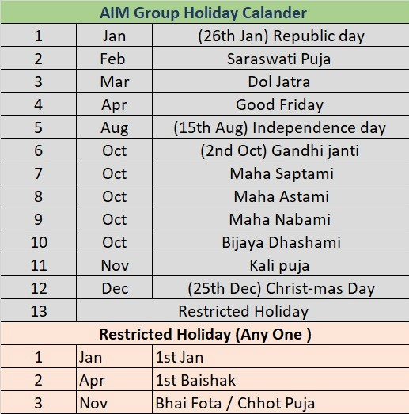

(B). Category-II:
Casual Leave:
No. of days- 0.5 to be credited per month i.e. 6 days every calendar year.
No casual leave can be availed if not credited previously. However, the balance of such leave can be credited to the following calendar year year/s. Application for Casual Leave should be forwarded through mail for due approval to concerned Manager . The leave should be approved; otherwise the leave will be treated as “Leave without Pay” (LOP).

(C). Category-III:
Sick Leave:
No. of days- 6 to be credited every calendar year.
In one incident, one should avail Sick Leave for minimum 3 days to maximum 6 days. If sick leave is applied for more than 6 days the extra leave will be deducted from CL balance if available, otherwise will be treated as “Leave without Pay” (LOP). Medical Certificate issued from a professional doctor or from the authority of a hospital to the effect to prove the authenticity of the sickness, should be enclosed with the application, without which Sick Leave will not be granted and the entire period of leave will be treated as “Leave without Pay”. Number of days for not availing such “Sick Leave” in any calendar year, will not be brought forwarded to the following year.

- Target & Cut-off :
Every employee should shoot the “Target” frame-work as below. In case of shooting or over-shooting of “target”, extra remuneration as incentive will be awarded in addition as per chart.
In case of anyone not achieving the target amount, she/he will be warned from AIM Digitalise to rectify the daily activity so as to develop to reach to the reasonable level of “Target”.
In case of anyone not achieving the Cut-off target amount, salary for the month will be hold. The with-hold amount will be released on next month or the following months along with the ensuing month’s salary, if the ensuing month’ target together with the short fall amount of cut-off target is achieved.
Your Target for FY 2023-24 is Rs. 80,000/- per Month

